**Emergent.sh Analytics Intern**

Gautam Manu

B.Tech CSE (2026)

Jaypee Institute of Information Technology, Noida-62

**GitHub:** <https://github.com/gautam642/Emergent.sh-metrics>

**Tableau link:** <https://public.tableau.com/views/Book1_17476387685290/Emergent_shmetricsDashboard?:language=en-US&:sid=&:redirect=auth&:display_count=n&:origin=viz_share_link>

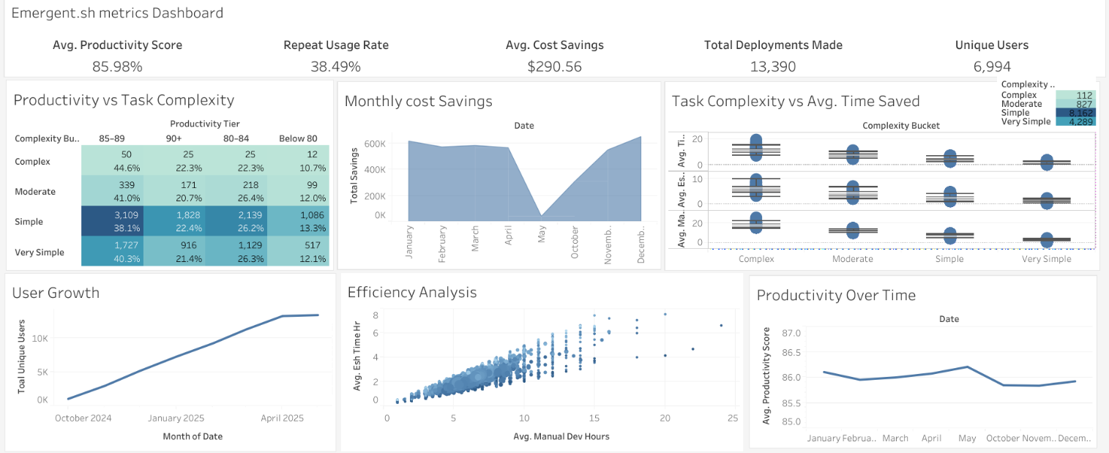

**Agentic Insights Assignment**

**1. Assignment Overview**

**Objective:** Pitch the Agentic (Emergent.sh) Platform to a data‑savvy investor by demonstrating impact through three core lenses: effectiveness, stickiness, and ROI.

**Deliverables:**

* **Three key metrics** to prove product efficacy
* **Mock dashboard** (Tableau/Google Sheets) with synthetic data
* **Narrative insights** (three lines) interpreting the data

My approach involved: ideation via Gemini, synthetic event/data simulation, metric computation, and Tableau dashboard creation.

**2. Key Metrics: Definitions, Formulae & Rationale**

**2.1 Agentic Productivity Score**

* **Definition:** Composite index measuring quality (success rate) and speed (time saving).
* **Formula:** Productivity Score = 0.7 * Success Rate % + 0.3 * (1 - Avg Platform Time / Manual Dev Time) * 100
* **Rationale:** 70% weight on delivery quality (interruption‐free runs), 30% on time savings—prioritizing reliability.

**2.2 30‑Day Repeat Usage Rate**

* **Definition:** Proportion of users who run ≥2 projects within 30 days of their first usage.
* **Formula:** Repeat Usage Rate (%) = (Number of users with at least one revisit within 30 days / Total unique users) * 100
* **Rationale:** Gauge platform stickiness; top‑quartile benchmarks are ~35–45% for dev tools.

**2.3 Avg. Cost Savings per Deployment**

* **Definition:** Dollar savings comparing manual vs. AI‑assisted build cost (at $50/hr vs. $1/hr).
* **Formula:** Cost Savings = (Manual Hours * 50) - (Avg Platform Hours * 1)
* **Rationale:** Direct ROI metric for investors; highlights financial value delivered per project.

**3. Data Generation & Preprocessing Pipeline**

We synthesized a dataset of 13,390 AI builds spanning October 2024–April 2025.

**3.1 Idea Generation via Gemini API**

# High‑volume ideation using Google Gemini (gemini‑2.0‑flash)

prompt = (

f"Generate {batch_size} unique 1–2 line project ideas, "

"with estimated manual dev hours (e.g., '4 hr'). Return JSON array."

)

# Rate‑limited to 15 calls/min, 1499/day

# Dedupe via rapidfuzz;

* **Outcome:** project_ideas.csv with {id, idea, manual_dev_hours}.
* **Reasoning:** Demonstrate an AI‑driven use case and seed realistic per‑project complexity.

**3.2 Cleaning & Enrichment**

* **Load & parse JSON** into DataFrame.
* **Extract numeric hours** from strings; convert to float.
* **Drop duplicates** via fuzzy matching (threshold 90%).

**3.3 Date & User Event Simulation**

**Assign random date** within 2024-10-01 to 2025-04-30.

df['date'] = np.random.choice(pd.date_range('2024-10-01','2025-04-30'), len(df))

**Simulate user signup & revisit events:**

- Monthly cohorts (200 → 5,000 new users per month).

- 40% chance of forced “return” 5–30 days later.

- Additional visits via exponential inter‑arrival (λ=1/15 days).

**3.4 Data Smoothing & Cohort Assignment**

1. Match each project to a user active on that date (exact or random fallback).

2. Recompute `repeat_flag`: revisit ≤30 days marked `1`.

3. Cap runs: max 5 projects per user in any rolling 7‑day window; otherwise impose 7–30 day cooldown.

**3.5 Metric Calculations**

For each record:

baseline_cost_usd = manual_dev_hours * 50

esh_cost_usd = avg_time_hr * 1

cost_savings_usd = baseline_cost_usd - esh_cost_usd

success_rate_pct = max(0, 100 - success_flag*5)

productivity_score = clip(

0.7*success_rate_pct + 0.3*(1 - avg_time_hr/manual_dev_hours)*100,

0,100

)

**Save** final DataFrame to project_metrics_smoothed.csv.

**4. KPIs & Dashboard Components**

Below are the chosen visualizations and why each was selected to tell our story.

**4.1 Top KPI Strip**

* **Metrics:** Avg. Productivity, Repeat Usage %, Avg. Cost Savings, Total Deployments, Total Unique Users.
* **Purpose:** Instant snapshot of platform health and scale.

**4.2 Productivity vs. Task Complexity Heatmap**

* **Axes:** Complexity buckets (Very Simple → Complex) × Productivity tiers.
* **Why:** Shows quality distribution across task difficulty—evidence that even complex tasks largely succeed.

**4.3 Monthly Cost Savings Area Chart**

* **Y:** Total $ savings per month
* **Why:** Tracks financial impact over time; highlights seasonal lift and growth.

**4.4 Task Complexity vs. Avg. Time Saved Scatter + Box Whisker**

* **X:** Manual Dev Hours
* **Y:** Avg. Platform Time Hours
* **Why:** Visualizes absolute time saved by task size; boxplots reveal consistency and variance.

**4.5 User Growth Line Chart**

* **Series:** Monthly unique users
* **Why:** Demonstrates adoption trajectory and market fit velocity.

**4.6 Efficiency Analysis Bubble Scatter**

* **X:** Manual Hours, **Y:** Platform Hours, **Bubble size/color:** Productivity Score
* **Why:** Multi‑dimensional view of per‑project ROI—higher scores at lower Y/X ratios.

**4.7 Productivity Over Time Line Chart**

* **Y:** Avg. Productivity Score by month
* **Why:** Monitors platform quality stability and seasonality; assures long‑term consistency.

**5. Insights & Next Steps**

* **Strong ROI:** ~$290 savings per deployment.
* **High reliability:** Avg. productivity ≈86%.
* **Healthy stickiness:** 38.5% 30‑day repeat rate.
* **Growth opportunity:** Increase volume and top-tier performance on complex tasks.